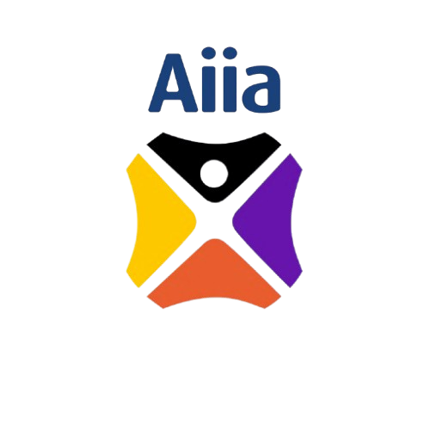 | Artificial Intelligence Initiative Africa  75 Hebert Chitepo Ave, Harare, Zimbabwe  +263 78 6434 998 admin@aiInitiativeafrica.com  www.aiinstituteafrica.com
Financial Proposal
Project Plan | Deliverables | Number  of Days | Assessments | Unit Price  per session | Cost
Training readiness assessment | 6 sessions | 3 days | 0 | $166.66 | $1000
Board Training | 3 sessions (2 physical, 1 online) | 2 1/2 days | 1 | $833.33 | $1500
Exco | 3 sessions (2 physical, 1 online) | 2 1/2 days | 1 | $833.33 | $1500
Management | 3 sessions (2 physical, 1 online) | 2 1/2 days | 1 | $833.33 | $1500
Support Functions (HR, Risk, Audit) | 3 sessions (2 physical, 1 online) | 2 1/2 days | 1 | $833.33 | $1300
Branches (Southern) | 3 sessions (2 physical, 1 online) | 2 1/2 days | 1 | $433.33 | $1300
Technical | 3 sessions (2 physical, 1 online) | 2 1/2 days | 1 | $433.33 | $1300
Branches (Northern) | 3 sessions (2 physical, 1 online) | 2 1/2 days | 1 | $433.33 | $1300
Total Excluding VAT |  |  |  |  | $10 700

 | Artificial Intelligence Initiative Africa  75 Hebert Chitepo Ave, Harare, Zimbabwe  +263 78 6434 998 admin@aiInitiativeafrica.com  www.aiinstituteafrica.com

Procurement Reference Number: AFC10/2026
Subject of Procurement: Provision of Artificial Intelligence Training
Name of Consultant: AI Initiative Africa
Consultant's Reference Number:

Date of Financial Proposal: 18 May 2026

The total price of our proposal is: USD 10,700.00 (United States dollars Ten Thousand and Seven Hundred Dollars Only). Excluding VAT

We confirm that the rates quoted in our Financial Proposal are fixed and firm for the duration of the validity period and will not be subject to revision or variation or adjustment.

Financial Proposal Authorised By:
Signed | 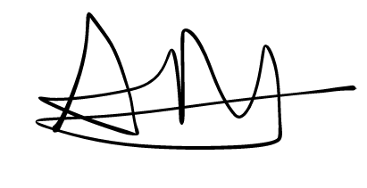 | Name: | Arthur Magaya
In capacity of: | CEO | Date: | 10 July 2026
Duly authorised for and on behalf of:
Firm | AI Initiative Africa
Address: | 75 Herbert Chitepo Avenue, Harare
Corporate Seal (where appropriate)

 | Artificial Intelligence Initiative Africa  75 Hebert Chitepo Ave, Harare, Zimbabwe  +263 78 6434 998 admin@aiInitiativeafrica.com  www.aiinstituteafrica.com
Summary of Costs
{Complete this form to summarise all the costs together from the breakdown of costs and submit it as part of your financial proposal.}
Item | Costs
 | [Indicate Currency]
Fees | $10,700.00
Reimbursable Costs | 0
VAT | Excluding VAT
Total Cost of  Financial Proposal (Excluding VAT) | $10,700.00

 | Artificial Intelligence Initiative Africa  75 Hebert Chitepo Ave, Harare, Zimbabwe  +263 78 6434 998 admin@aiInitiativeafrica.com  www.aiinstituteafrica.com
Currency of Costs: USD
FEES
Name and Position of Personnel | Input  Quantity | Unit  of  Input | Unit Rate | Total Price
Dr Martin Maduva | 5 | Sessions | $559.25 | $3 020
Dr Tendai Zengeni | 5 | Sessions | $559.25 | $3 020
Dr Gombiro | 5 | Sessions | $559.25 | $3 020
Mr Rupere | - | Sessions | $559.25 | $1,640
Sub Total: | 25 |  |  | USD 10 700
Financial Proposal Authorised By:
Signed |  | Name: | Arthur Magaya
In capacity of: | CEO | Date: | 10 July 2026
Duly authorised for and on behalf of:
Firm | AI Initiative Africa
Address: | 75 Herbert Chitepo Avenue, Harare
Corporate Seal (where appropriate)

